**BANK LOAN REPORT QUERY DOCUMENT**

**By – Yogesh Kumar Chaurasiya**

**LinkedIn -** www.linkedin.com/in/yogeshchaurasia

1. **BANK LOAN REPORT | SUMMARY**

**KPI’s:**

**Total Loan Applications**





**MTD Loan Applications**

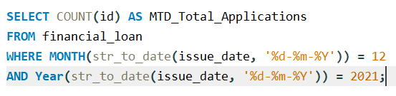



**PMTD Loan Applications**

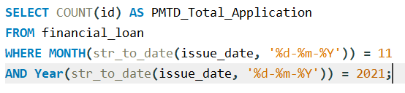



**Total Funded Amount**





**MTD Total Funded Amount**

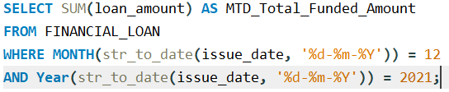



**PMTD Total Funded Amount**

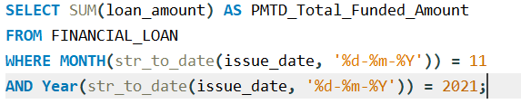



**Total Amount Received**





**MTD Total Amount Received**

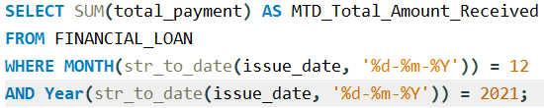



**PMTD Total Amount Received**

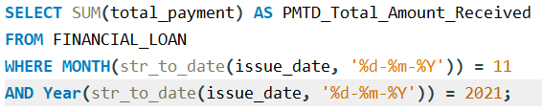



**Average Interest Rate**





**MTD Average Interest Rate**

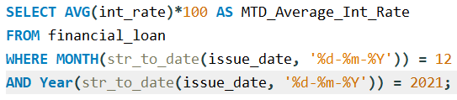



**PMTD Average Interest Rate**

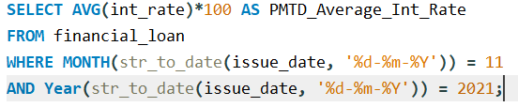



**Avg DTI**





**MTD Avg DTI**

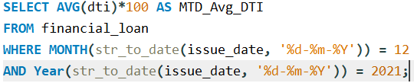



**PMTD Avg DTI**

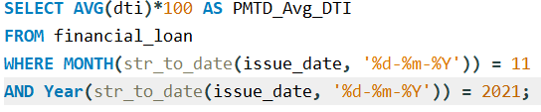



**GOOD LOAN ISSUED**

**Good Loan Percentage**

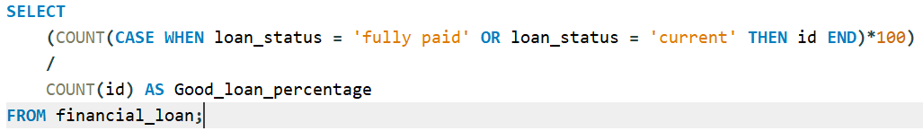



**Good Loan Applications**

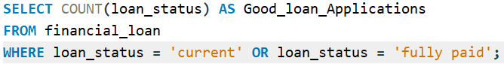



**Good Loan Funded Amount**

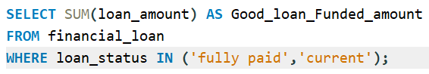



**Good Loan Amount Received**

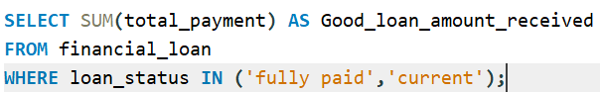



**BAD LOAN ISSUED**

**Bad Loan Percentage**

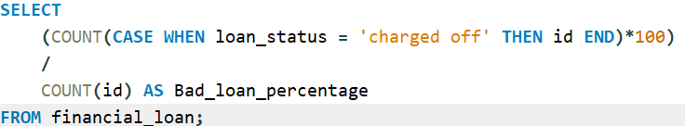



**Bad Loan Applications**

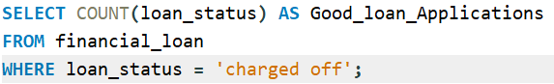



**Bad Loan Funded Amount**

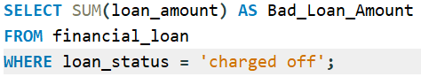



**Bad Loan Amount Received**

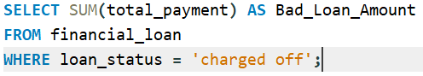



**Loan Status**

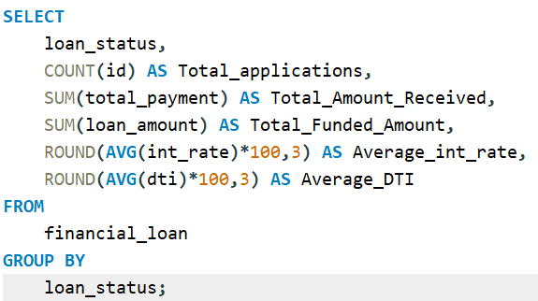

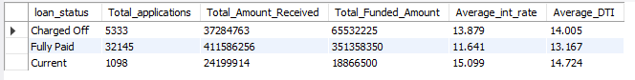

**MTD Loan Status**

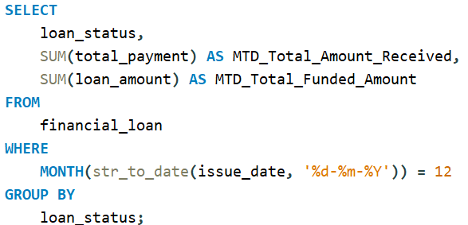

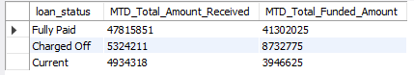

**BANK LOAN REPORT | OVERVIEW**

**MONTH**

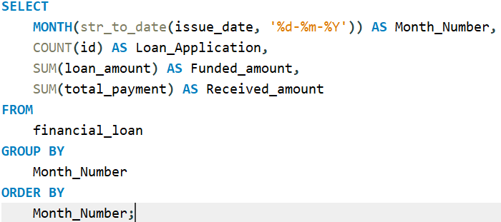

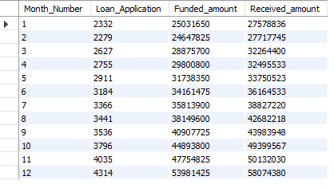

**STATE**

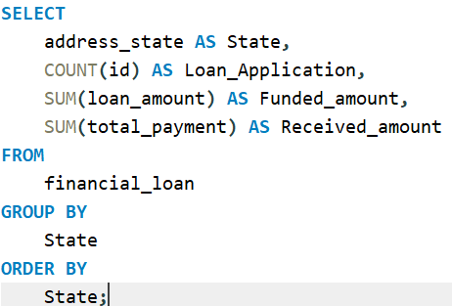

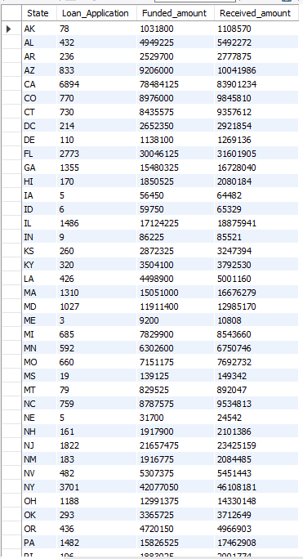

**Term**

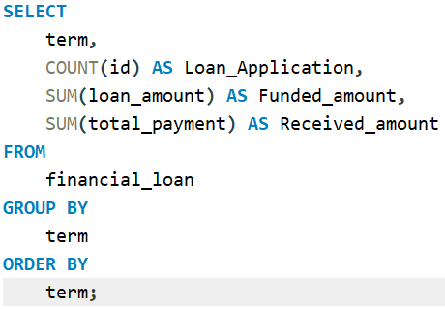

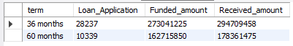

**Employee Length**

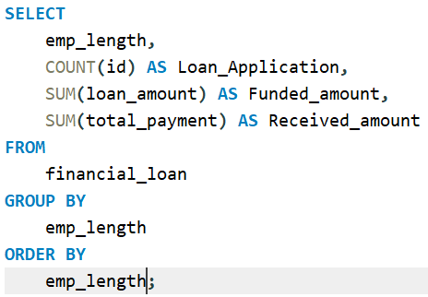

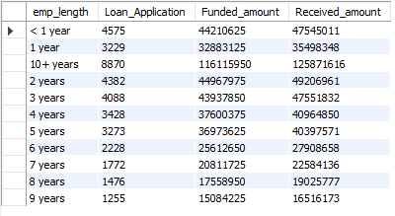

**Loan Purpose**

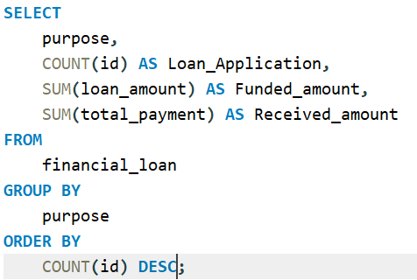

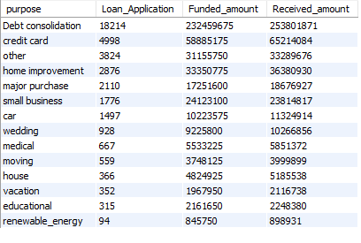

**Home Ownership**

